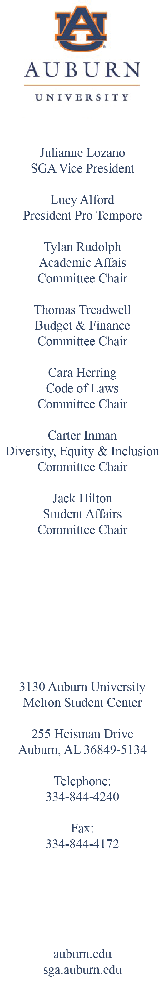
Open Forum

Roll Call

- Approval of the Minutes

- Reports of Officers, Colleges, and Standing Committees

- Reports of Special Committees and Liaisons

- Current Orders of Business

- Future Orders of Business
  - PSSB-23-0220-01
  - PSSB-23-0220-02
  - PSSB-23-0220-03

Announcements

Adjournment

BILL TO: Student Senate
FROM: Lucy Alford, At-Large
RE: Chief of Staff Approval
DATE: February 20, 2023
PSSB: 23-0220-01

I ask for approval of the following:

Jillian Daugherty, Executive Chief of Staff

BILL TO: Student Senate
FROM: Lucy Alford, At-Large
RE: Executive Vice President of Initiatives Approval
DATE: February 20, 2023
PSSB: 23-0220-02

I ask for approval of the following:

Dylan Peterson, Executive Vice President of Outreach

BILL TO: Student Senate
FROM: Lucy Alford, At-Large
RE: Executive Vice President of Initiatives Approval
DATE: February 20, 2023
PSSB: 23-0220-03

I ask for approval of the following:

Maddie Robison, Executive Vice President of Initiatives

