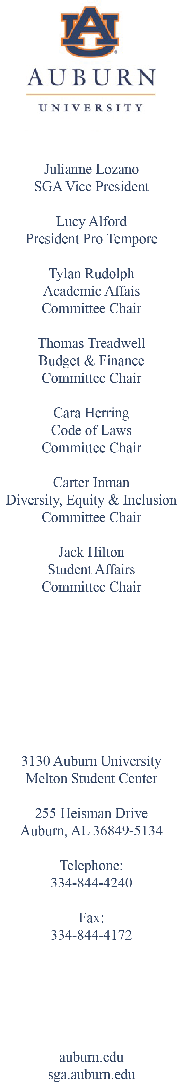
Open Forum

Roll Call

- Approval of the Minutes

- Reports of Officers, Colleges, and Standing Committees

- Reports of Special Committees and Liaisons

- Current Orders of Business

- Future Orders of Business
  - PSSB 23-0821-01
  - PSSB 23-0821-02
  - PSSB 23-0821-03
  - PSSB 23-0821-04

Announcements

Adjournment

